**North Seattle Pediatrics Behavioral Health Program**



We are excited to offer additional support for our patients’ behavioral concerns here at North Seattle Pediatrics (NSP).

***What is this program?***The integrated behavioral health (IBH) program offers brief interventions for patients with emotional and behavioral health concerns such as depression, anxiety, or difficulty managing stressors (school, friends, family, relationships). The patient and family work closely with their PCP and our behavioral health specialist to determine the most appropriate treatment plan. If the patient could benefit from additional specialty or community resources, the IBH team will also help coordinate external referrals. Our behavioral health provider will have resources through Ryther, Seattle Children’s Hospital and will be overseen by a Psychiatric Consultant.

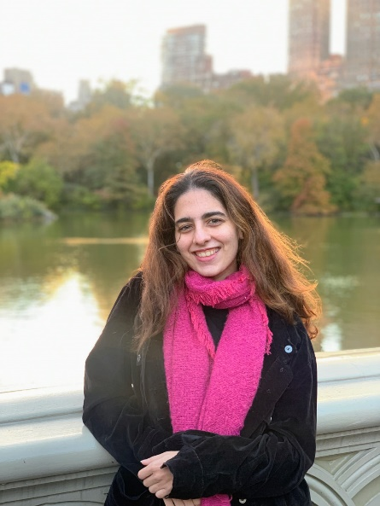***Who is it for?*** Any NSP patient, 5-18 years old who does not already have a mental health provider

***How does it work?*** You (the parent/guardian and/or patient) and your doctor will decide if meeting Maitreyee, our behavioral health specialist, will be beneficial. She will gather information and you will usually meet for 30-60 minutes a week here in the office, virtually, or by phone.

***How long do services last?*** Our model is designed to be an interactive, flexible, short term intervention. Depending on the issue to be addressed, the length of the treatment plan may vary. On average, we expect to work together over 3-12 weeks.

***What does it cost?*** This will be billed to your medical insurance, which may be subject to copay, deductible, etc. for most commercial insurers. Upon request, our billing staff can provide you information if you would like to verify benefits.

Maitreyee Sathe, LMHCA

Maitreyee is a mental health clinician who grew up in India and moved to New York where she received her graduate degree in Mental Health Counseling from New York University. Extremely passionate about working with children and families, Maitreyee is dedicated to creating a supportive, safe, and non-judgmental environment for her patients. She utilizes evidence-based and trauma-informed therapeutic modalities that are tailored to meet the unique needs and goals of each child while considering the influence of cultural and social factors. Within her area of expertise, Maitreyee is particularly interested in parent-child interactions and early childhood development. Outside of her professional life, Maitreyee enjoys being outside, closer to the nature. She loves hiking in the mountains and is super excited to explore all the outdoor opportunities that Seattle has to offer.

